The database design is described below

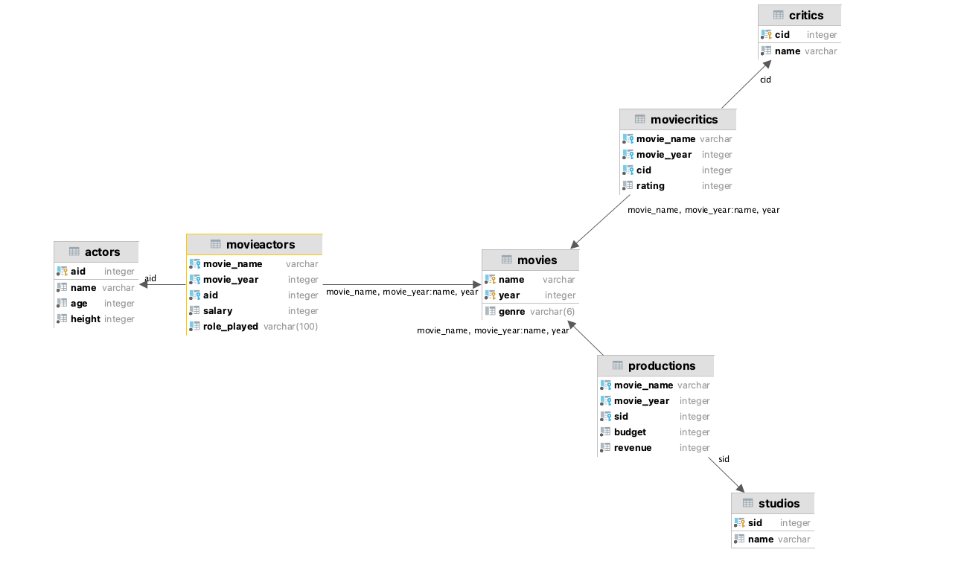

We have 4 basic tables which are describing Movies, Actors, Studios, and critics.

For each one the fields are exactly the same as the class described in the file.

Actor:

* aId (Integer): the id of the actor, it’s a primary key because first, it must be unique and secondly creating an index on this field will accelerate the queries and because it will be used as a foreign keys in some tables and finally it must not be null.
* Name (Varchar): A not null string describing the name
* Height (Integer): A not null integer describing the height of the actor, with the constraint height > 0
* Age (Integer): A not null integer describing the age of the actor, with the constraint age > 0

Movies:

* Name (Varchar): The name of the movie (more on this one next)
* Year (Integer): The year of the movie’s release. A movie is identified with the fields name and year, so we decided to define the pair as the primary for the same reasons as aId in actors
* Genre (Varchar(6)): The string that describe the genre of the movie. We used a constraint to ensure that it’s one of the following (Drama, Action, Horror, Comedy)

Studio:

* sId
* Name

Critics:

* cId
* Name:

Moreover, as we can see on the diagram, the first described tables are related by some tables that allows us to respond to the needs of the basic API operation such as

ActorPlayedInMovie, CriticRatedMovie, StudioProducedMovie (and the ones with “didn’t”)

MovieActors:

* Movie_name (Varchar): Name of the movie where the actor played
* Movie_year (Integer): Release year of the movie where the actor played, it’s a foreign key together with Movie_name, that are referencing name and year of the table Movie
* aId (Integer): Id of the actor that is playing in the corresponding movie. It’s a foreign key that is referencing to the aId field of the Actors table
* Salary (Integer): The salary of the actor for this movie, in order to ensure that the salary is not negative we put the constraint Salary > 0 for this field.
* Role_played (Varchar): One of the role that the actor play in the movie

Note: If an actor plays two different roles in the same movie, there will be two different rows for this actors and movie with two, each one having a different role. The unique constraint is on the fields (Movie_name, Movie_year, aId, Role_played )